Starting tracking system

1. Turn on tracking system, you can refer to FasTrak User Manual, [“Getting Started”](C://Polhemus/FasTrak/FasTrak%20User%20Manual%20OPM00PI002-G.pdf) (Note: installation has already been completed of software on computer this is simply for plugging in system)
2. Open PDImfc
3. This should pop up:

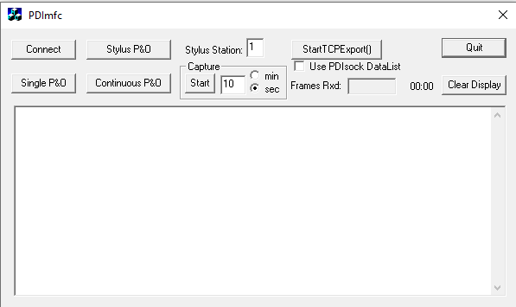

4. Click Connect

5. Click StartTCPExport()

Note: you may need to wait for connection to be established after step 4 & 5

6. Click Continuous P&O: continuous readings should begin to appear on interface.

7. Open MATLAB

8. Open files: PNO_data.m , fstclient.m and PNO_initial.m

9. Run: PNO_initial.m (gives reference point/point of stability)

10. Run: PNO_data.m (gives points as data in matlab for LabVIEW to process)

Labview Valves

1. Open LabView
2. In “Open Existing” select file: Valve_Control.VI (select “Capstone project” 🡪 “Valve_Control.VI”)
3. Go to “Window” 🡪 “Show Block Diagram”
4. Make sure that the DAQ is connected to power.
5. Plug in the AC/DC converters in order to power all of the valves.
6. 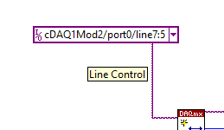Make sure to select the 6 corresponding port lines where the relay module (NI-9485) connects to the valves. (Using the I/O drop down menu seen on the right)

**Note: if wires have not been changed the current file should match the set up**

1. After starting the tracking system (see steps on the page above), run the LabVIEW program.

Pressure Sensors

1. In Labview, select “File” 🡪 “Open” 🡪 “Capstone Project” 🡪 “Pressure_Control.VI”
2. Go to “Window” 🡪 “Show Block Diagram”
3. All waveform graphs should correspond to the corresponding muscle. Therefore, DO NOT unplug pressure sensor wires from the module without labelling which channel they correspond to beforehand.) (NOTE: Channel pairing 0/8 may be faulty, we recommend not using them.)
4. Making sure that the DAQ is plugged in and turning on the power supply (13.8V) for the pressure sensors, run the labview program. (It doesn’t matter when this is run with respect to the other softwares as it only measures the pressure in the muscles.)